Name: Pranali Sonawane
Subject: MCSA
Date: 16-12-2025
Lab: Install VMware Tool and Configure Logon and Logoff script

Install VMware Tool:
Server 1:
Click on VM Install VMware Tools This Pc DVD Drive D is show
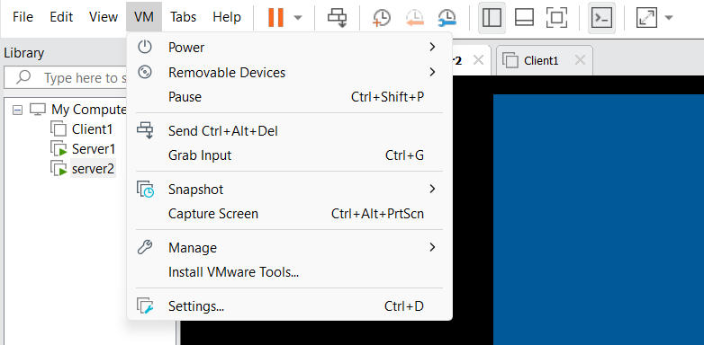
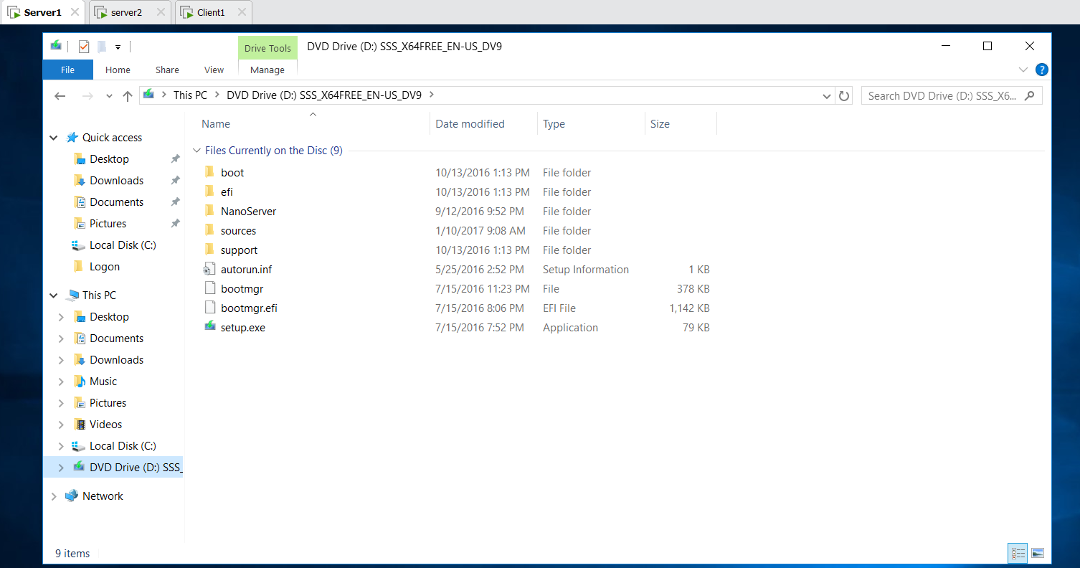

In Main C Drive Download FireFox Setup146.0
In server1 copy the FireFox Setup 146.0 past on Server1 Desktop
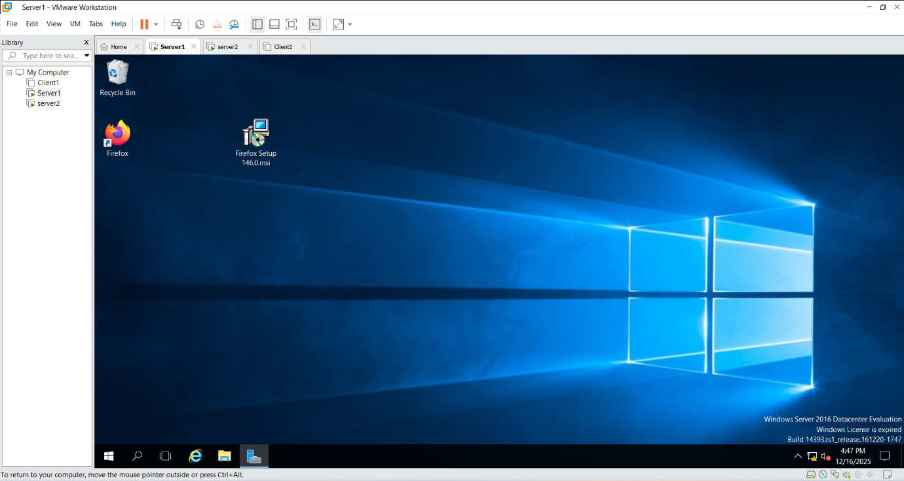
In Server1 C drive Create Software Folder Give Sharing and Security Full Control Permission

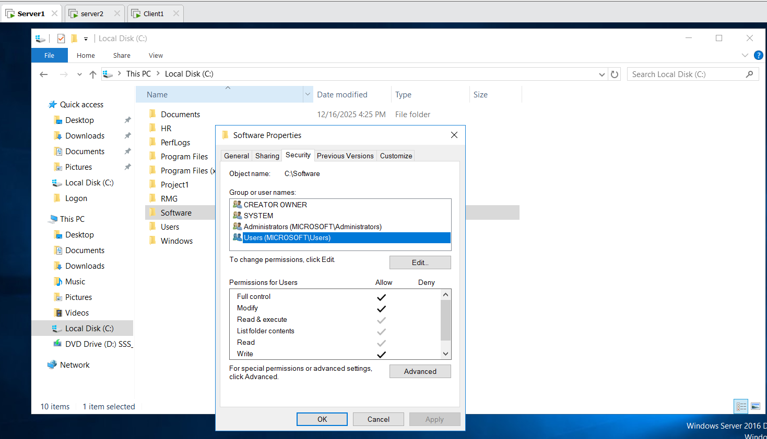

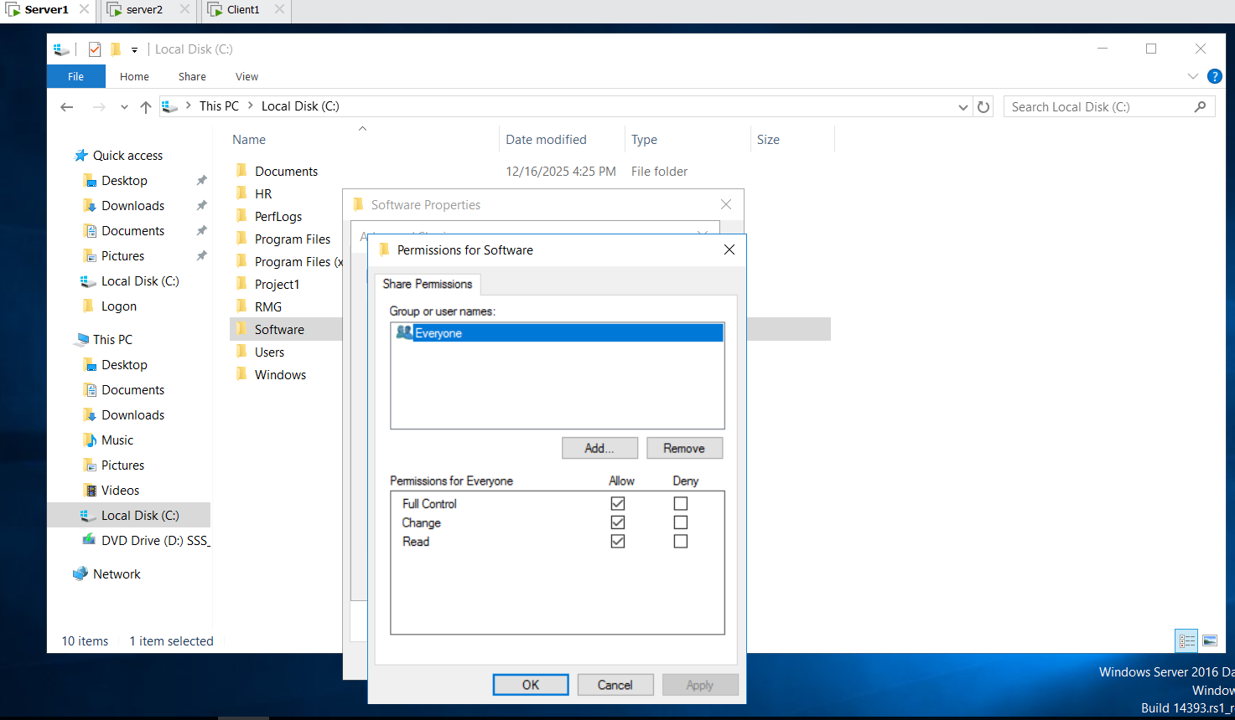

Tools Group Policy Management Microsoft.com Default Domain Policy Right Click Edit Computer Configuration Policies Software Settings Software Installation new Package \\server1\Software\ FireFox Setup 146.0
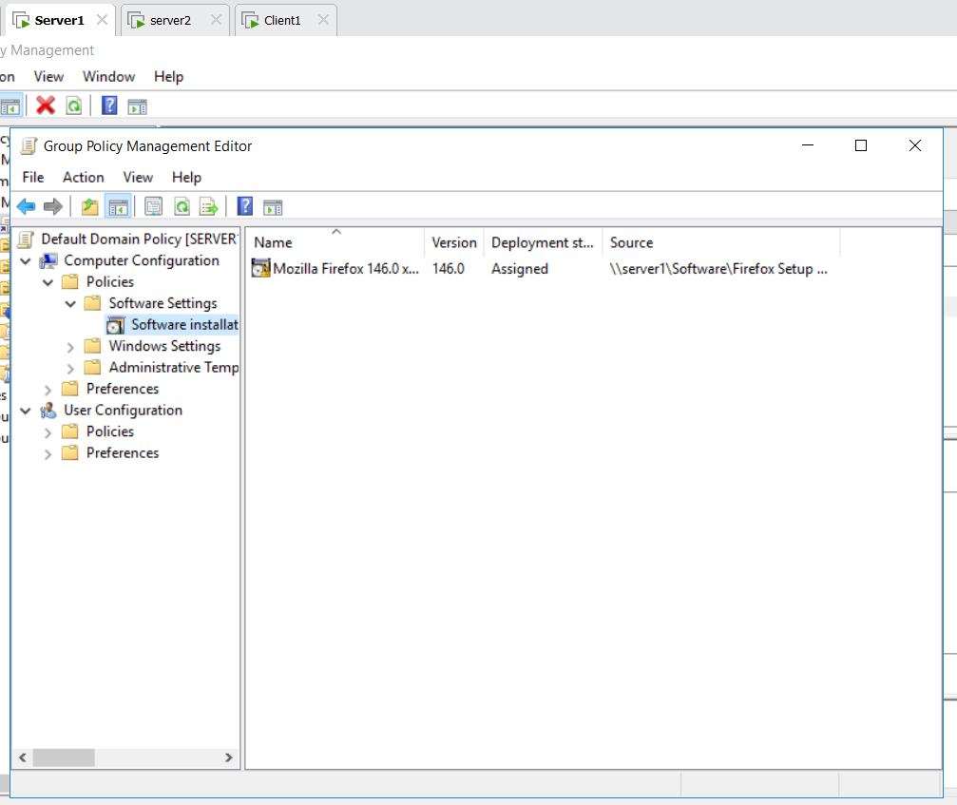

In Server2: FireFox On the Desktop
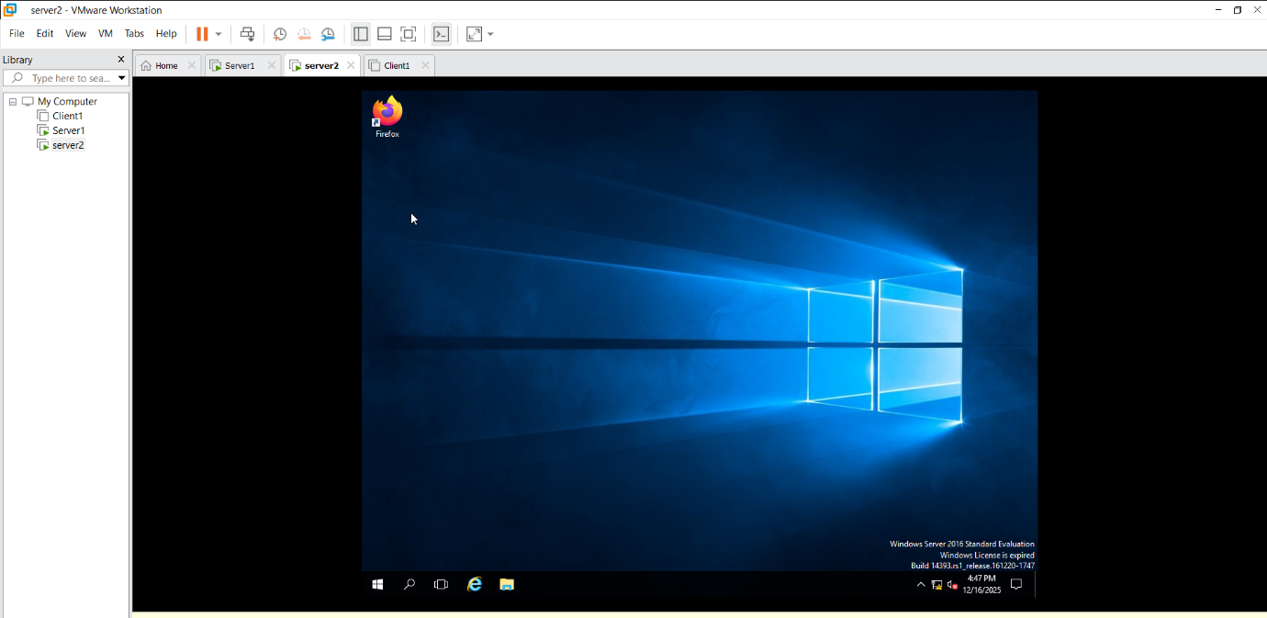

In Client1: FireFox On the Desktop

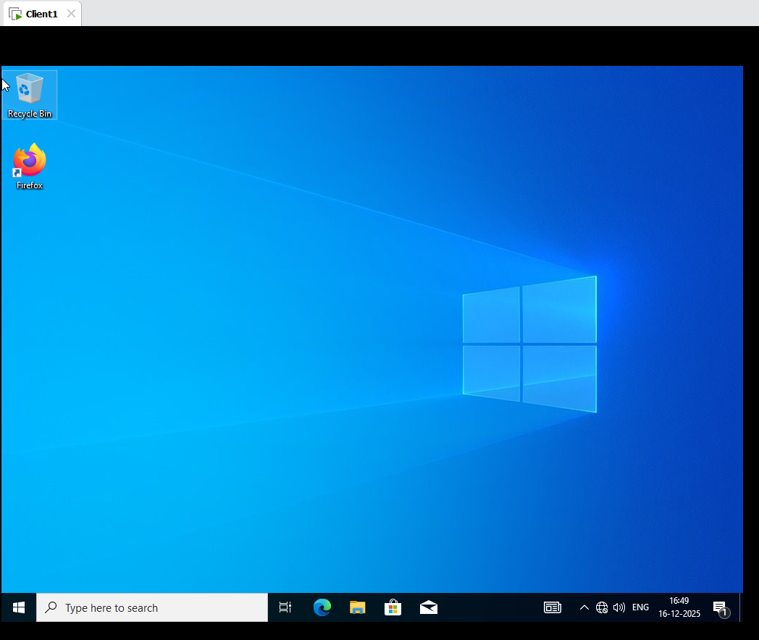

Configure Logon and Logoff script:
Configure Logon Script:
Tools Group Policy Management Microsoft.com Default Domain Policy edit Go the Default Domain Policy User Configuration Policies Windows Settings Scripts(Logon and Logoff) Logon Add Browse create document Logon.bat extension (only .bat extension not txt extension)
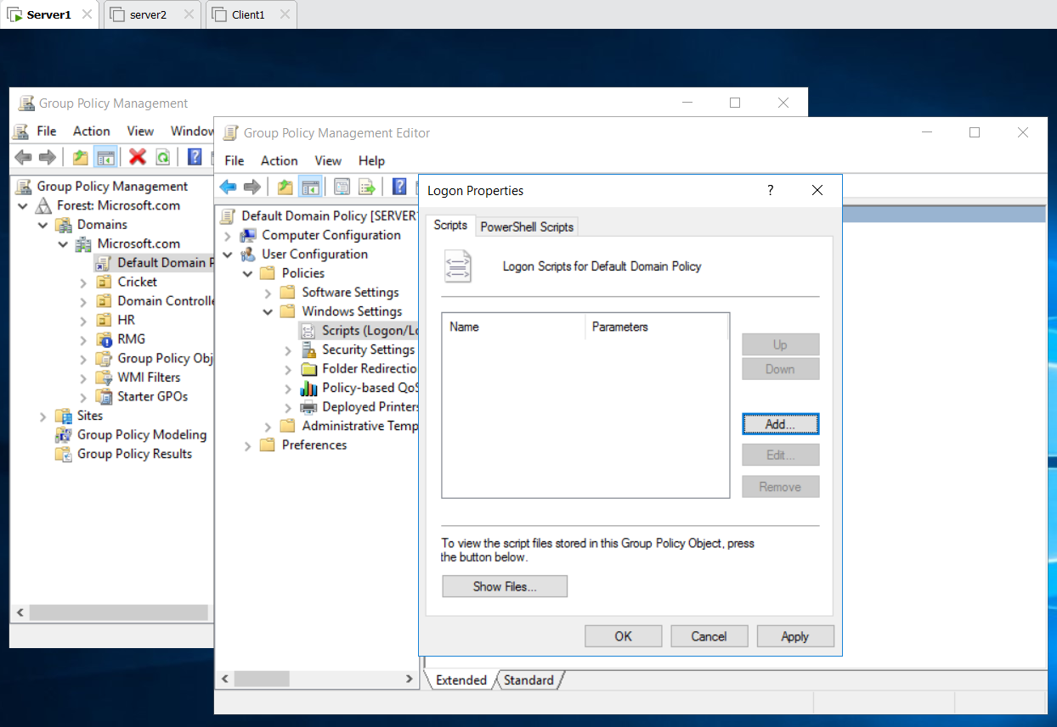
Logon.bat write :
@echo off
msg * “Welcome %username%”
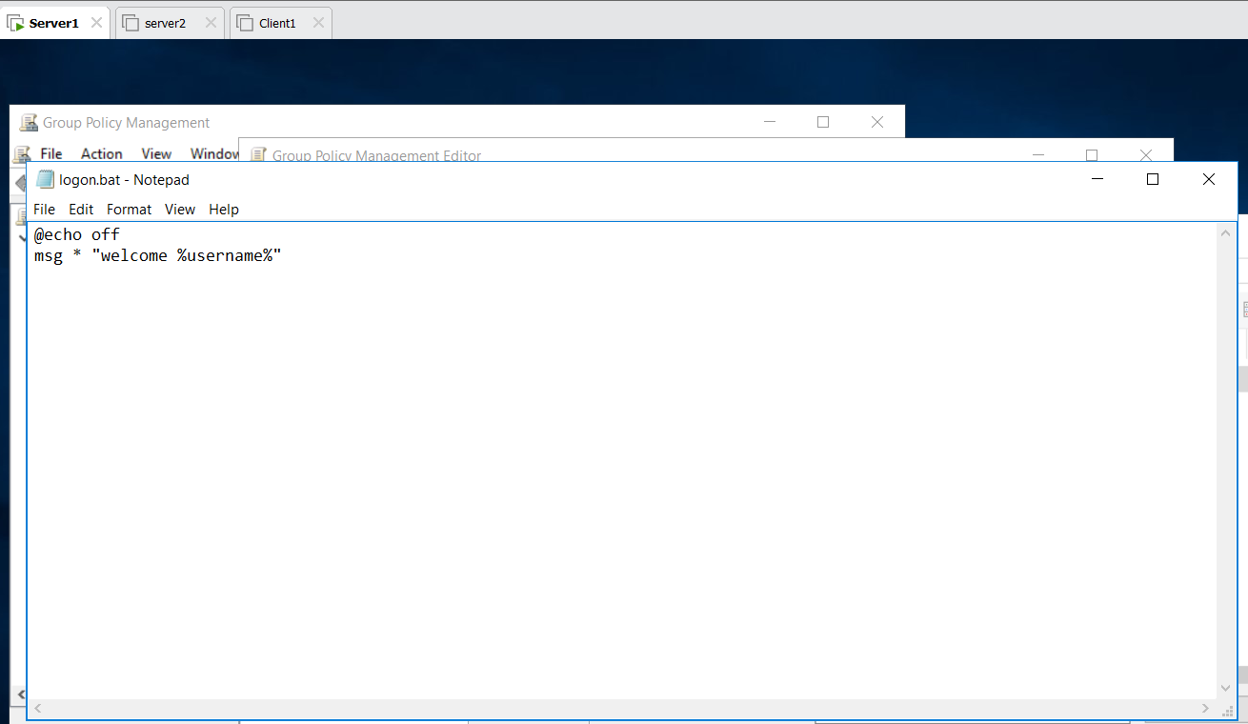
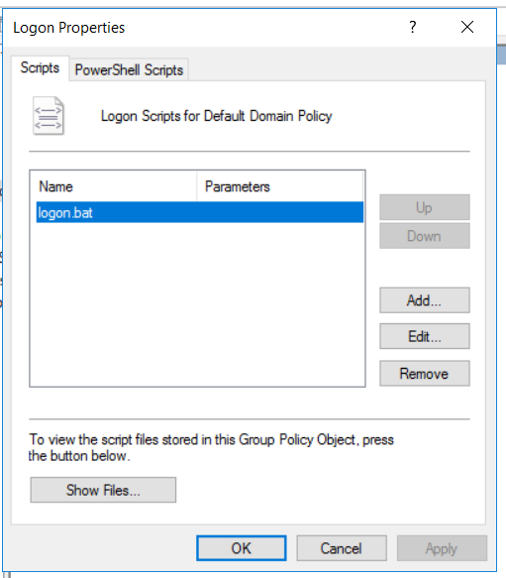
Then Server 1 Restart Welcome Administrator
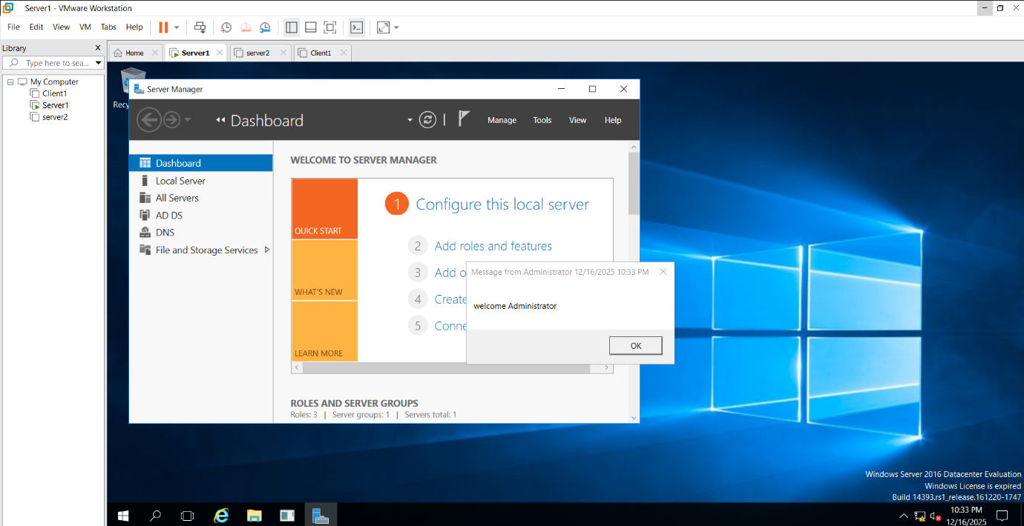
Configure Logoff script:
Tools Group Policy Management Microsoft.com Default Domain Policy edit Go the Default Domain Policy User Configuration Policies Windows Settings Scripts(Logon and Logoff) Logoff Add Browse create document Logoff.bat extension (only .bat extension not txt extension)
Logoff.bat write :
@echo off
msg * “User %USERNAME % is Logging off “

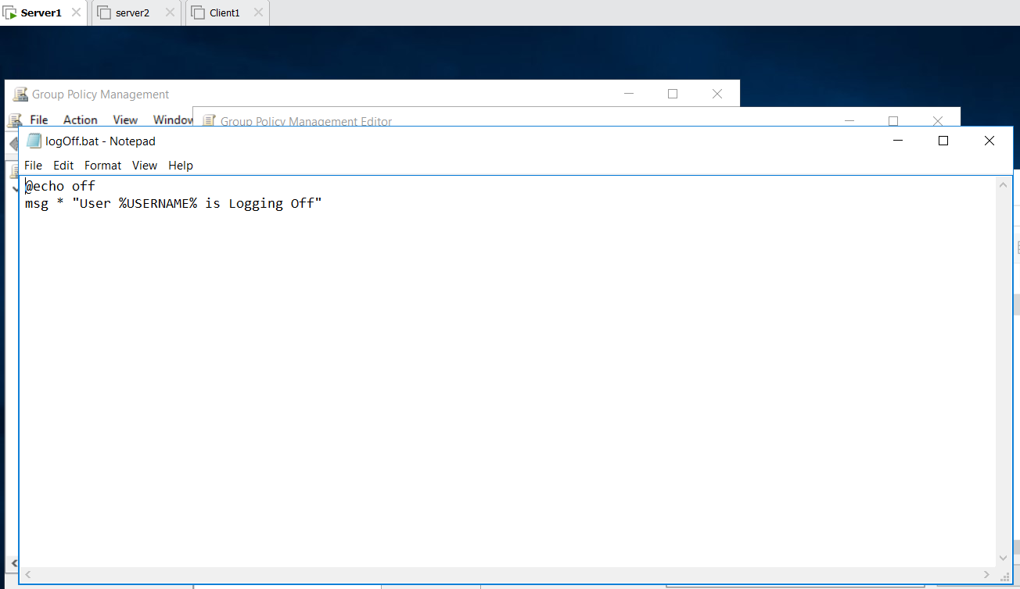

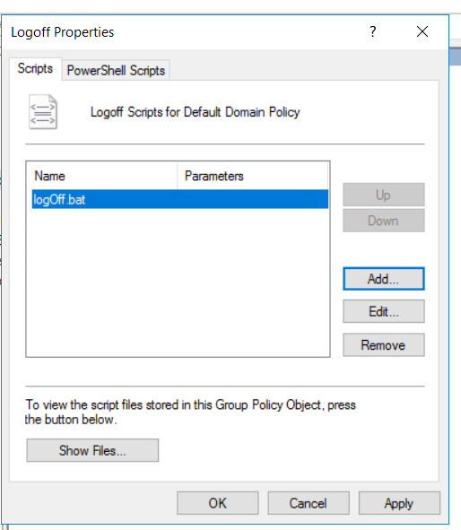
Server 1 Logoff Show User Administrator is Logging Off
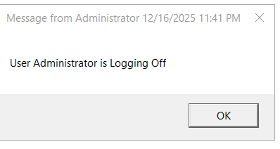

Server 2 :
Login on : Username : shiv
Password: Password@123
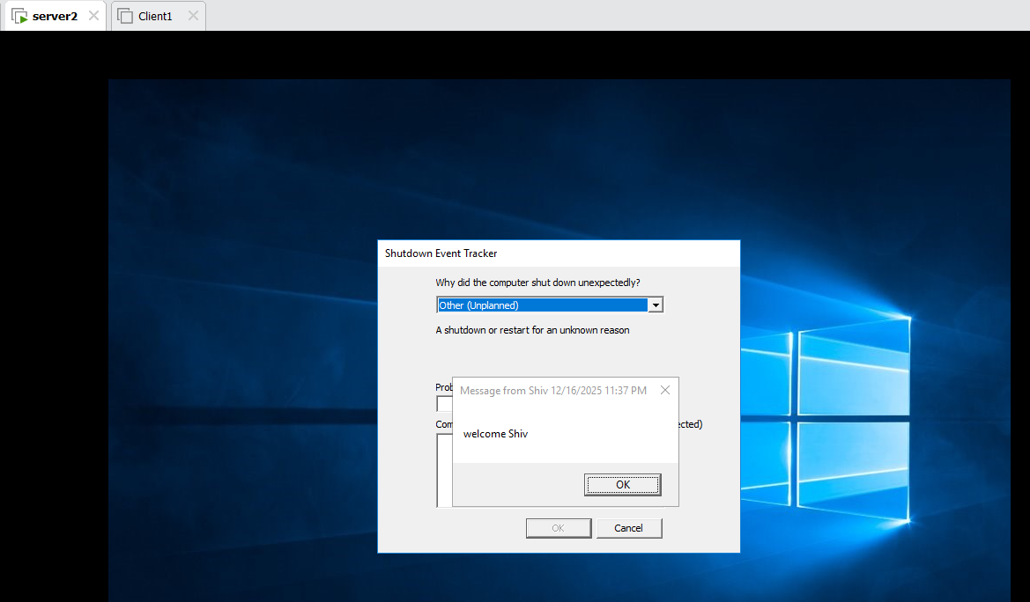
Logoff Message show
Client 1:
Login on : Username : Pooja
Password: Password@123
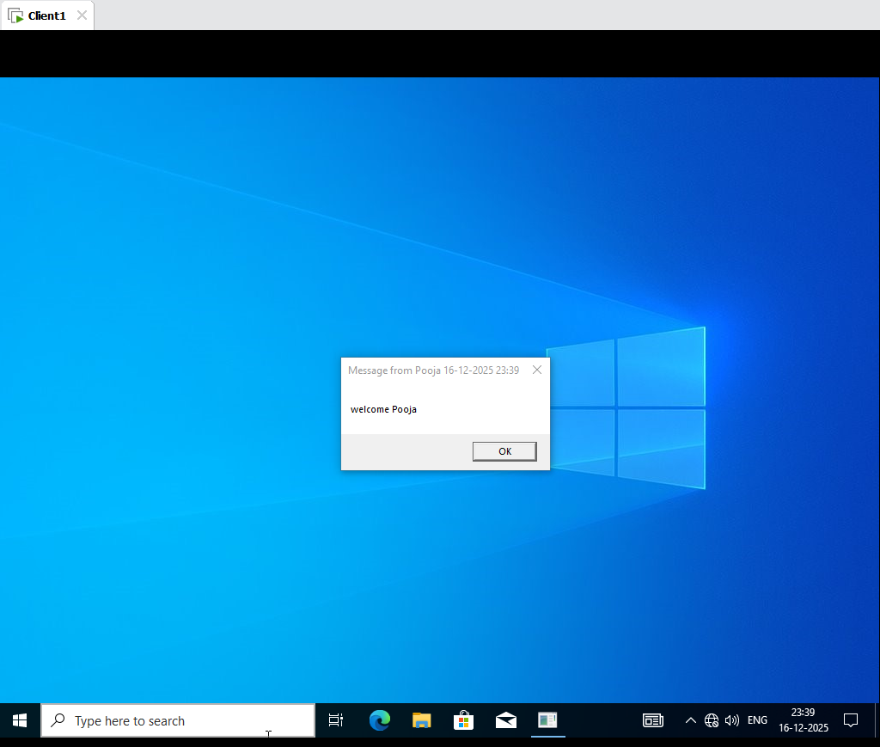
Logoff Message show
Not Working : cmd gpupdate/force

Same for Startup and Shutdown Script.

